REDX MITAOE

TEAM: KSHATRIYA

In second week ,we discussed about artificial intelligene,it’s application and importance. Artificial intelligene becomes the important part of our daily life.We can say Artificial intelligence is the machine which are designed and programmed in such a manner that they do and think and act like a human.Our life is changed by AI because this technology is used in a wide area of day to day services.These technology reduce human effort.

Now, in many industries,people are using these technology to develop machine slaves to perform the different activity. Using the machine for the work speed up your process of doing work and give you an accurate result.

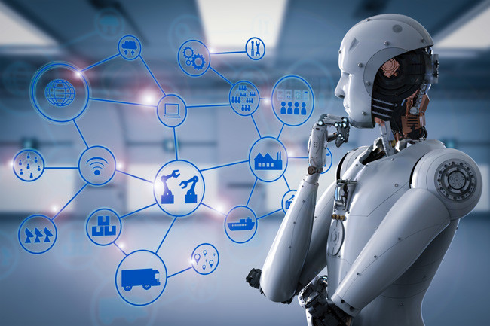
The introduction of AI brings the idea of error free world. This technology will slowly introduce in all the sector to reduce human effort and give accurate and faster result.

